**Policy to access only one bucket out many buckets**

first we have to list all our bucket and then select particular bucket to access in another statement.

“ListAllMyBucket” shows only the list of bucket, I dosen’t open the list of object inside the bucket, unless you select the particular bucket to list its object in second statement.

**Policy to access only one bucket out many buckets**

{

"Version": "2012-10-17",

"Statement": [

{

"Sid": "Statement1",

"Effect": "Allow",

"Action": [

"s3:GetBucketLocation", --------------this line is optional

"s3:ListAllMyBuckets" ----------this line mandatory otherwise it shows access denied error,

First we have to list the available bucket and we select particular bucket to access.

],

"Resource": [

"arn:aws:s3:::*"

]

},

{

"Sid": "Statement2",

"Effect": "Allow",

"Action": [

"s3:*" -----------------you can mention, GetObject,PutObject……etc, here

],

"Resource": [

"arn:aws:s3:::kvs-webserver",

"arn:aws:s3:::kvs-webserver/*" ------ you can also mention particular object here

]

}

]

}

It list all the bucket but permit you to access only the mentioned bucket{kvs-webserver}

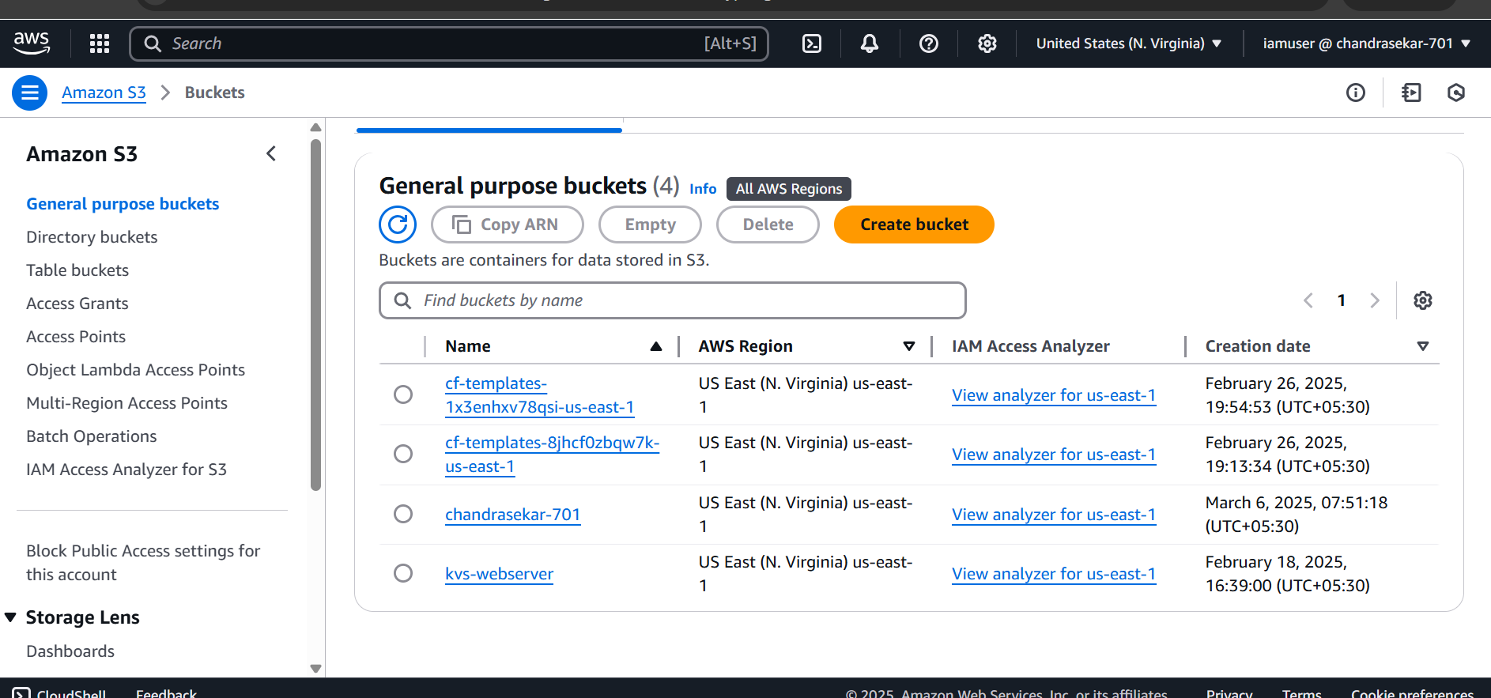

It shows access denied error. If you didn’t mention the **“s3:ListAllMyBuckets”**

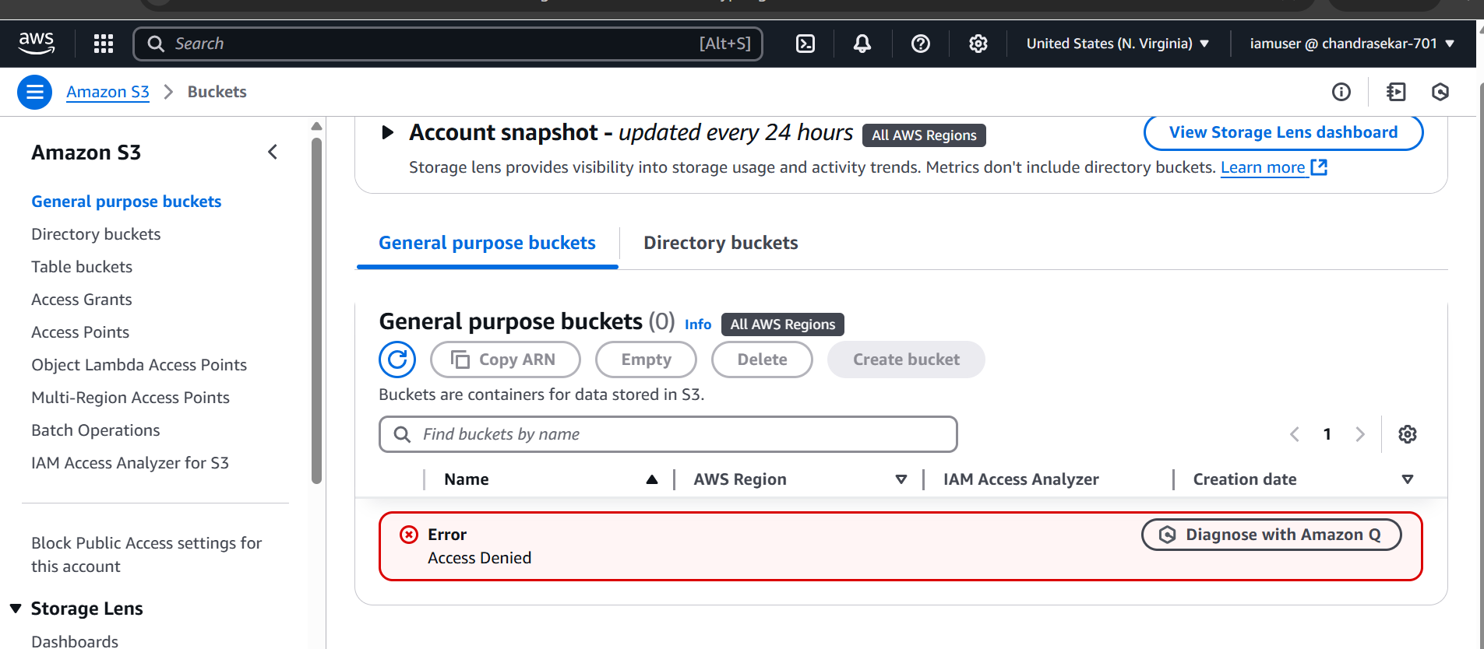

While trying to see the object of other bucket

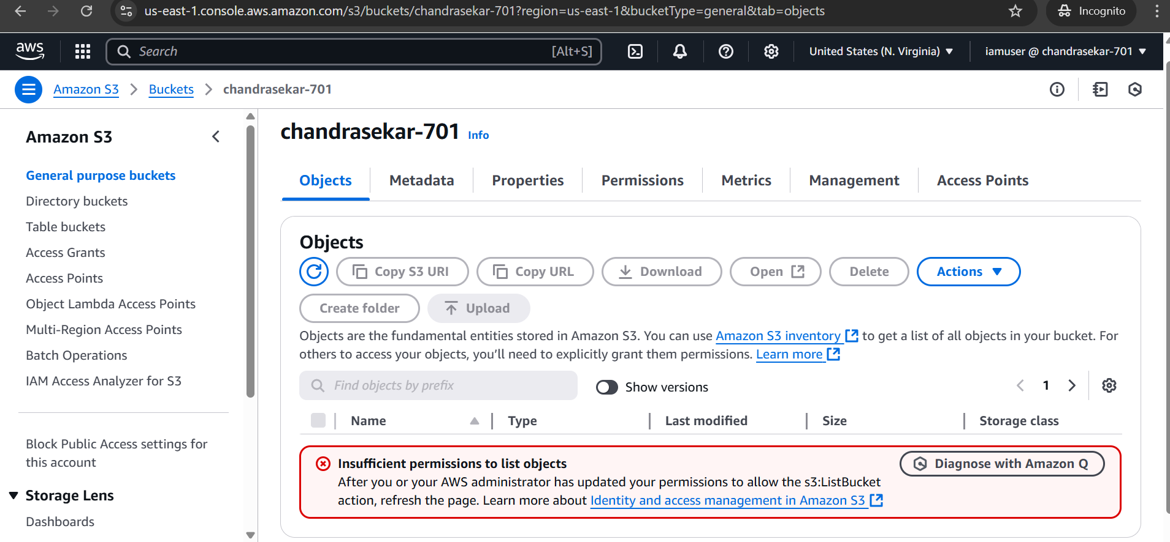

It list all the object in the kvs-webserver, which I mentioned in the policy file

